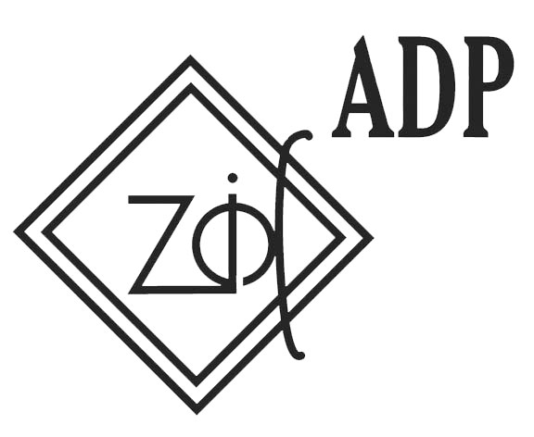

CALL FOR PARTICIPANTS
Seminar for Youth Leaders
Routing of social responsibility in SEE region on
priorities of Social inclusion young peoples recognized
in Declaration “Agenda 2020”

27. August - 03. September 2009
Niksic, Montenegro

Dear,

I am pleased to inform you that Association of Democratic prosperity – Zid preparing seminar for youth leaders from 27.08. to 03.09. Seminar will be held in Niksic, Montenegro. Main topics of the seminar are social exclusion, social responsibility and Youth policy on national and European level.

The objectives of the seminar are:

- To increase quality of work youth NGO’s, particularly from SEE country, true work with young multipliers and improvement there knowledge and skills related to social responsibility;
- To increase skills and knowledge of 25 participants about other countries’ realities, especially related to social exclusion disadvantages groups of young peoples and youth policy;
- To secure exchanges examples of good practice and develop tools in non-formal educations of young peoples;
- To increase capability of youth leaders to develop and support social responsibility programs that have an aim to increase level of integration of young people who are socially and economically disadvantaged and strengthening there possibilities to access the job;
- To promote main decision and declaration adopted in the Council of Europe and to encourage the contribution of young people and youth organizations to the implementation of the priorities at local and national levels;
- To promote understanding among participants in the spirit of the core values of the Council of Europe true youth co-operation on international level.

Aims of the seminar:

Main aim of the seminar is to qualifying youth leaders to build their own capacity and contribute to higher level of engagement of all sectors in programs that are aiming to decrease isolation of disadvantages groups of young peoples and support their transition form education to the labor market.
During the seminar, Youth leaders will have opportunity to learn how to use social responsibility projects in terms of social exclusion. This project will give them opportunity to participate in the debate, build self-confidence and improve their communication skills.

Working methods:

The seminar for Youth leaders will be based on non-formal education to improve knowledge of participants referring the main topic of the meeting. It will be based on the learning by participation methodology, taking into account the participants’ needs and interests.

The methods used over the seminar will be:

- Visual presentations
- Group work,
- Group discussions and brainstorming
- Group debates
- Role-play
- Case studies
- Good practice examples

Working languages: English

Participants: 25 participants,

Advantage during the selection would have participants who have work or voluntary engagement in organization where they can use and implement knowledge, experience and connections from this seminar.

Eligible Countries: Italy, France, Germany, Hungary, Turkey, Croatia, Romania, Bulgaria, Bosnia and Herzegovina, Serbia, Macedonia, Moldova and Albania.

Financial conditions: 70% of the travel cost covered.

Participation fee: 35,00€

Deadline for applications are 15. July 2009.

For more information, please contact us by email: exchange@zid.org.me

